
Supreme Vision SV-301R WIRELESS ENTERTAINMENT SYSTEM
Operating Manual
Important Guidelines:
Please read the instructions in this guide before installing and using the equipment.
Use the power adapter provided with the equipment. Plug the power adapter into an appropriate grounded power outlet or connect the cable to a C-safe port on cardio machines.
Do not place anything on top of or over the equipment. Doing So can damage the membrane switch and electronics.
Do not attempt to service the unit yourself. Please contact your dealer or SupremeVision directly for maintenance and replacements.
Product Description:
The 3-Band wireless entertainment system is the latest development in 3-band technology. This new wireless receiver is easy to mount on stationary fitness equipment. It covers all entertainment frequency ranges, allowing the user to listen to a TV or other audio source connected to a compatible 2.4 GHz transmitter, all 900 MHz transmitters, and all FM radio transmitters. With its unique large LCD design and membrane control buttons, it is attractive and user friendly. It allows the user to SCAN to find the 900MHz and FM frequencies being used in the area. The scanning sensitivity is adjustable for different environments. 10 levels of squelch sensitivity are flexible and convenient for the installers to utilize the most appropriate settings.
Specifications:
Mode | 2.4 GHz Frequencies | 900 MHz Frequencies | FM Frequencies
Frequency | 2.4 GHz - 2.4835 GHz ISM | 902.000 - 928.000 MHz | 88 MHz – 108 MHz
Sensitivity | -94 dB mW | -98 dB mW | -99 dB mW
Frequency space | 6.048 MHz | 50 KHz | 100 KHz
Audio Sampling | 24-bit/48 KHz sample rate stereo | analog
Current Draw | 110 mAh | 45 mAh | 28 mAh
Audio Frequency Response | 20 Hz to 20 KHz | 50 Hz to 15 KHz
Mute | audio mute when signal lost
Audio Input / Output | 3.5 mm audio jack
Operating Voltage | 4.75~10 V

Configuration of the SV-301R
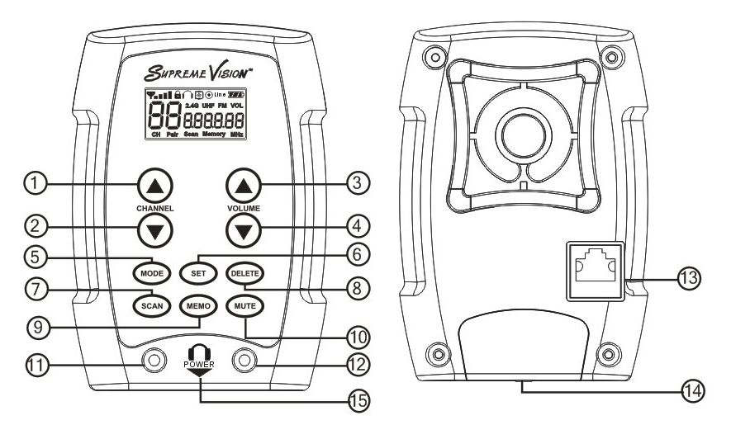

1. CHANNEL UP Button
2. CHANNEL DOWN Button
3. VOLUME UP Button
4. VOLUME DOWN Button
5. MODE Button
6. SET Button
7. SCAN Button
8. DELETE Button
9. MEMO Button
10. MUTE Button
11. SCREW 1 (used to change the headphone jacks)
12. SCREW 2 (used to change the headphone jacks)
13. RJ45 CONNECTOR (connect a cable to a ground outlet or a C-safe port on the cardio machine)
14. REPLACEABLE HEADPHONE JACK
15. PLUG IN HEADPHONE TO TURN ON THE POWER

Programming Procedures
- Power ON/OFF: The unit turns on instantly when the headphone is plugged into the headphone jack. The unit turns off 7 seconds after the headphone is unplugged.
- Volume/Channel Setup: The LCD shows the Signal Strength, Channel #, Mode, and Volume Level. The user can change the Channel # by using the CHANNEL UP & CHANNEL DOWN buttons. Adjust the Volume level by using the VOLUME UP & VOLUME DOWN buttons.
- Mode Selection: Use the MODE button to switch among three modes, i.e., 2.4 GHz Frequencies, UHF (900MHz) Frequencies, and FM Frequencies.
- Squelch Setting: The receiver squelch setting is activated by pressing the DELETE and MUTE buttons for ten seconds in the selected mode. Use VOLUME UP or VOLUME DOWN buttons to adjust the level (from 0 to 9). Return to the selected mode by pressing the DELETE and MUTE buttons for ten seconds again.
- Programming: Press SET and MEMO buttons for ten seconds to activate the setting mode. Press them again for ten seconds to return to the selected mode.
2.4GHz Mode: Use the CHANNEL UP or CHANNEL DOWN buttons to scroll through the 14 channels of the 2.4 GHz band (only). Use VOLUME UP or VOLUME DOWN buttons to switch between the two groups. The group without “PAIR” mark is compatible with the Group 1 of our SV-301GT 2.4GHz wireless entertainment transmitter; the group with “PAIR” mark is compatible with the Group 2. If any of the 14 listed channels are unwanted, press MEMO button till the “Memory” on the LCD will disappear. Press again to recover it.
900MHz / FM Mode: In the 900 MHz mode, the scanning covers all the frequencies from 902 MHz to 928 MHz using 50 k spacing. The FM is from 88 MHz – 108 MHz, so it scans all the frequencies in this bandwidth using 100k spacing.

- Start auto scanning by pressing the SCAN button once. Before that, if required, choose the scanning sensitivity level by scrolling up or down the 16 frequency groupings (from 0 to F) using the DELETE button. The factory setting is 5. It takes approximately 80 seconds for the 900 MHz system to complete the auto scanning, while it takes approximately 35 seconds for the FM system to finish the auto scanning. When it detects an FM signal, it will add that frequency to the scanned list.

- When auto scanning is complete, use the VOLUME UP or VOLUME DOWN buttons to review the scanned list. At this time, choose the Channel # by the CHANNEL UP or CHANNEL DOWN button, then choose the wanted frequency from the scanned list. For example, set the Channel # at 01, and then select frequency 89.7 from the scanned list. Finally, hold the MEMO button down till “Memory” flashes once, which means that the frequency and Channel are successfully enabled.
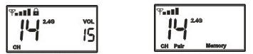
2.4GHz normal mode/setting mode
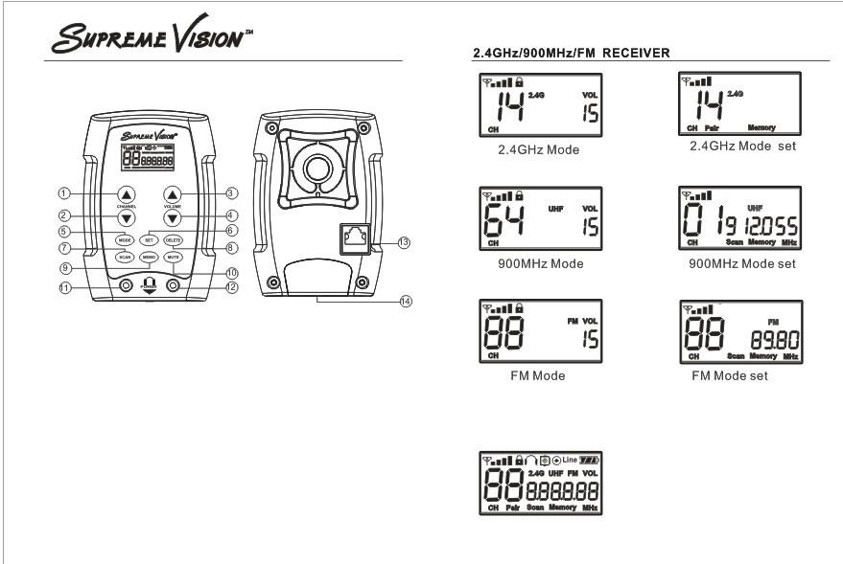
900MHz normal mode/setting mode

FM normal mode/setting mode

Special Note:
Because a frequency might be needed later, it is suggested that none be deleted from the scanned list. This saves rescanning, which can mess up previous settings. Further, the scanned list can be used as reference information when a new transmitter is being set up. Up to 64 channels can be selected for both the 900 MHz and FM systems. The receiver stops auto scanning after it collects the 64th channel. In areas where there is a lot of noise or interference, adjust the scanning sensitivity level for better results.
Installation:
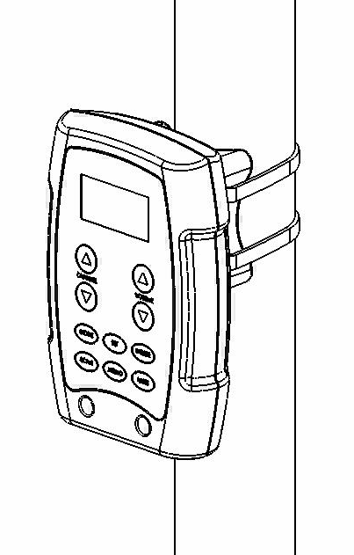
Use the enclosed cable (zip) ties to attach the wireless receiver to the cardio equipment. Please place the wireless receiver in a position on the machine that will not cause any interference with range of motion or safety features.
  - Identify the fitness equipment on which you plan to attach the receivers. Determine a location on the equipment where the person can comfortably reach it and the controls are easily readable. Make sure that the receiver does not interfere with the equipment’s display or moving parts. You can attach a receiver either horizontally or vertically. Do not attach the receiver to handlebars that move.
  - Insert two cables through the holes in the mounting bracket on the back of the receiver. Place the receiver onto the handlebar. Use the pliers to tighten the cable ties so the receiver cannot move.
  - Cut off the excess plastic from the cable ties, being careful not to leave any sharp edges.
Note: The user is allowed to vary the receiver direction without removing the receiver, by one hand holding the mounting bracket and the other hand lifting the receiver up and rotating to the desired direction/location.
Replacing Headphone Jacks:
- Loosen the two screws on front. Slide the headphone jack module out of the compartment. The headphone jack module can be changed without removing the wireless receiver from the cardio machine! Place the new headphone jack module back into the wireless receiver compartment and tighten the two screws.
- The headphone jack should be replaced after it has been used 6,000 times. The LCD shows the number of uses when the unit is powered on. After 6,000 uses, the headphone icon will be flashing on the LCD. After you replace the new headphone jack, there are two methods to zero the counting.
  - Use a needle or a thin tool to press the button inside the jack compartment to zero the counting.
  - Plug in the headphone to power on the receiver, press SET and MEMO buttons for ten seconds to activate the setting mode, and press DELETE and MUTE buttons for eight seconds till the flashing headphone icon disappears.
FCC Compliance Statement: This equipment has been tested and found to comply with the limits for a class B digital device pursuant to part 15 of the FCC rules.
These limits are designed to provide reasonable protection against harmful interference when the equipment is operated in a residential environment. This equipment generates, uses and can radiate radio frequency energy and if not installed and used in accordance with this instruction manual may cause harmful interference to radio communications. However, there is no guarantee that interference will not occur in a particular installation. If this equipment does cause harmful interference to radio or TV reception, which can determined by turning the unit off and on, the user is encouraged to try to correct the interference by one or more of the following measures:
. Reorient or relocate the receiver.
. Increase the separation between the equipment and the receiver.
. Connect the equipment to an outlet different from that to which the receiver is connected.
. Consult your dealer or SupremeVision or experienced A/V technician.
Repairs: In the event that there is need for repair, please contact SupremeVision for a Return Authorization.
SupremeVision (A Division of Supreme Audio, Inc.) 155 Troy Rd., P.O. Box 550 Marlborough, New Hampshire 03455
Phone: 1-800-213-3515 or 1-603-876-3636 Fax: 1-800-346-4867 or 1-603-876-4001
E-mail: Info@SupremeVision.com
Copyright © 2010 SupremeVision (A Division of Supreme Audio, Inc.) All Rights Reserved. (Revised 11/22/10)

