
USER’S MANUAL: SUPREMEVISION LARGE AREA FM WIRELESS ENTERTAINMENT TRANSMITTER
Model No.: SV-301FT

Introduction
Thanks for purchasing the SUPREMEVISION SV-301FT FM wireless entertainment transmitter. This system is very reliable and easy to use. It is supported by a professional technical team who will ensure that, in the unlikely event that you encounter any problems, you will be completely satisfied. Set the transmitter into any frequency within the range of 87.5MHz to 107.9MHz. The transmitter is compatible with all FM receivers worldwide.

Technical Specifications
SV-301FT FM Wireless Entertainment Transmitter
Frequency | 87.5MHz – 107.9MHz
Output Power | 10dbm
Frequency space | 50KHz
Channel | TBD
Audio Sampling | Analog
Current Draw | DC9V 180mA
Audio Frequency Response | 50Hz~15KHz
Mute | audio mute when signal lost
Transmission Method | FM
Audio Input / Output | Line Input, Digital Inputs (Coax. & Optical)
Power | 9V Power Adapter

Configurations
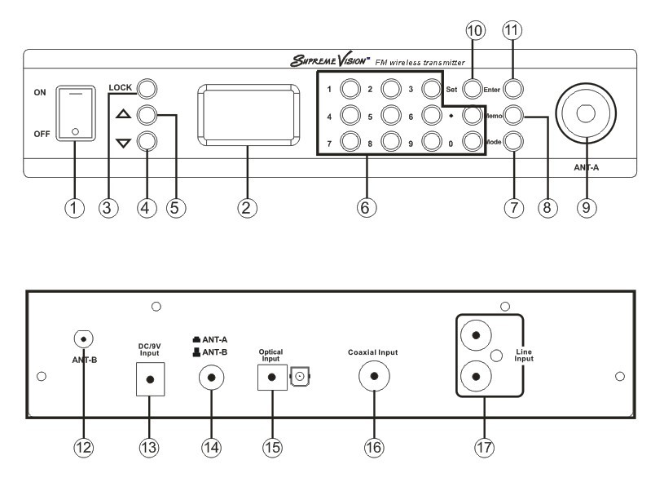
- ON/OFF Switch
- Color TFT Display
- Lock button
- UP button
- DOWN button
- Digit 0-9 & Decimal Button
- Mode button (used to select the audio source inputs: coaxial input, fiber input or line input)
- Memo button (used to memorize a new frequency)
- ANT-A (front antenna)
- Set button
- Enter button (used to confirm a new frequency)
- ANT-B (rear antenna)
- DC/9V power input Jack
- Antenna selection switch (used to select the front or rear antenna) Digital optical input jack
- Digital coaxial input jack
- Line input jack

LCD Display
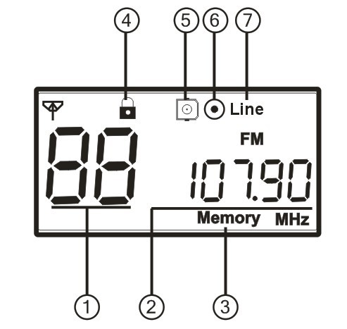
  - Volume (adjustable from 0 to 15, the volume icon flashes when there is no audio input or the input source mode selection is incorrect)
  - Frequency (see frequency setup details in programming procedures)

  - Memory icon (after inputting the frequency, the user must press the “Memory” to save the frequency, and you can see this icon flashing once on the display)

  - Lock icon (make sure to lock and unlock as per the instructions during operation)

  - Digital fiber input icon (make sure to change the mode to this icon when the audio source is connected to the digital fiber input jack)

  - Digital coaxial input icon (make sure to change the mode to this icon when the audio source is connected to the digital coaxial input jack)

  - Line input icon (make sure to change the mode to this icon when the audio source is connected to the line input jacks)

Programming Procedures

Transmitter volume setup: Use the UP/DOWN button to adjust the volume level (0-15) under lock status.

Frequency setup: Unlock by pressing the “LOCK” button till the lock icon disappears. The cursor defaults to the first digit. As you enter a digit for the new Frequency the cursor automatically moves to the right until you have entered all digits. Then press “Enter”. The decimal point is done automatically. If you make a mistake, you can start again or use the “UP”/ “Down” buttons to correct. Once you press “Enter”, the cursor will go away, and if you need to change, press “SET and start again. After inserting the wanted frequency, press “Enter” and then “Memory” to memorize the Frequency. Then the setting is done.

Input source selection: Use “Mode” button to choose the inputs (digital coaxial input, digital fiber input or line input) under lock status.

Antenna selection: The antenna selection switch has two depths. When you push it once, it goes deeper, and the system will use the front antenna. When you push it again, it is shallower, then the system uses the rear antenna.

Trouble Shooting Guide

- When STATIC INTERFERENCE occurs, please go through the following procedures to eliminate the problems.
- Sound level on TV or other audio source equipment may be too high. Check the equipment and adjust the sound level as needed.
- Check to see if any outside sources are using the same frequency as the transmitter. Either locate and remove the outside interference, or set the transmitter to a different channel to avoid that frequency.
- Check the antenna installation. Make sure the antenna selection is correct. Switch to the rear antenna if the front one doesn’t work, and vice versa. Check the audio source cable.
- Make sure the transmitter mode is correct and the receiver channel number is correct.
- Check the sound by connecting it to a different transmitter. Listen from a receiver to see if the sound improves.
- Make sure the transmitter has power by checking the AC power cord. Is it plugged into a nearby outlet and into the transmitter?
- Make sure that the antenna is upright and not located near a power cord or any metal objects.
- If the problem continues, unplug the power cord for five minutes, then plug in again

- When a NOISY SOUND occurs, please go through the following procedures to eliminate the problems.
- Make sure there are no major internal obstructions, such as metal support posts, between antenna and receiver.
- Make sure the antenna and receivers are installed so they are within the distance range.
- Make sure that the antenna is upright and not located near a power cord, audio cable, or any metal objects.
- Make sure the sound level on the TV or other audio source equipment connected to the transmitter is set to a reasonable, medium level.
- Try changing the transmitter to a different frequency to see if the sound quality improves. Some will be received better than others. A 300K frequency space is suggested to ensure the audio quality.
- Make sure no other wireless transmitters are using the same frequency at the facility. The user is encouraged to use our Tri-band wireless receiver to do an auto-scanning in the field before the installation to find out the frequencies being used. Avoid using the frequencies being used whenever you install a new transmitter.
- Check to see if any outside sources are using the same frequency as the transmitter. Either locate and remove the outside interference, or change the transmitter to a different frequency to avoid that frequency.

- When there is NO SOUND, please go through the following procedures to eliminate the problems.
- Make sure the transmitter and the receiver frequencies match.
- Sound from the TV or other audio sources may be too low or muted. Check the equipment and increase the sound or un-mute as needed.
- Check to see if the volume icon on the LCD display is flashing. Make sure the transmitter mode and the audio input jacks match.
- Make sure the audio cable is in the TV “OUTPUT” not the TV “INPUT”.
- Check the sound from the TV or other audio sources by connecting it to a different transmitter. Listen from a receiver to see if the sound improves.
- Make sure the transmitter has power by checking the AC power cord: Is it plugged into a nearby outlet and into the transmitter?
In case the problem persists, the unit needs to be serviced. Please contact your dealer or Supreme Audio for maintenance and replacements service.
Important Safety Instructions
Read all instructions in this guide before installing and using the equipment.
Use the supplied power supply with the equipment. Plug the power supply into an appropriate, grounded power outlet.
Keep the equipment away from water and moisture. Avoid dropping anything on the equipment.
Do not attempt to service the unit yourself. Contact your dealer or Supreme Audio directly for maintenance and replacements.
FCC Compliance Statement
This device complies with Part 15 of the FCC rules. Operation is subject to the following two conditions: a. this device may not cause harmful interference; b. this device must accept any interference received, including interference that may cause undesired operation.
The SV-301FT large area FM wireless entertainment transmitter has been tested and found to comply with the limits pursuant to Part 15 of CFR47, FCC Rules. These limits are designed to provide reasonable protection against harmful interference when operated in a residential installation. This equipment generates, uses and can radiate radio frequency energy and, if not installed and used in accordance with the manual instructions, may cause harmful interference to radio communications.
Warning: Per FCC rules, changes or modifications not expressly approved by the manufacturer could void the user’s authority to operate the equipment.

Repairs:
In the event that there is need for a repair, please contact SupremeVision for a Return Authorization.
SupremeVision (A Division of Supreme Audio, Inc.) 155 Troy Rd., P.O. Box 550 Marlborough, New Hampshire 03455
Phone: 1-800-213-3515 or 1-603-876-3636 Fax: 1-800-346-4867 or 1-603-876-4001
E-mail: Info@SupremeVision.com
Copyright © 2010 SupremeVision (A Division of Supreme Audio, Inc.) All Rights Reserved.
(Revised 11/22/10)

