
USER’S MANUAL:SUPREME AUDIO DIGITAL 900MHz SA95 Beltpack Transmitter
Model No.: SA95
Introduction:
Thanks for purchasing the SUPREME AUDIO digital 900MHz SA95 beltpack transmitter. This system is very reliable and easy to use. It is supported by a professional technical team who will ensure that, in the unlikely event that you experience any problem, we will work with you to solve it.
There are 12 channels available for this system which can work simultaneously.

Technical Specifications
SA95 900MHz Beltpack Transmitter
Frequency | 902.000MHz – 928.000MHz
Frequency space | 2 MHz
Channel | 12
Audio Sampling | 32KHz QPSK
Current Draw | 105mA
Audio Frequency Response | 20Hz~15KHz
Mute | audio mute when signal lost
Concurrent Systems | 12
S/N Ratio | 80dB
Audio Output | 1-Mini XLR mic input, 1-3.5mm mic input
Charging Current | 100mA average
LED | Green: working mode  Green flashing: low battery  Red flashing: charging  Red: fully charged
Power | 9V Power Adapter

Configuration:
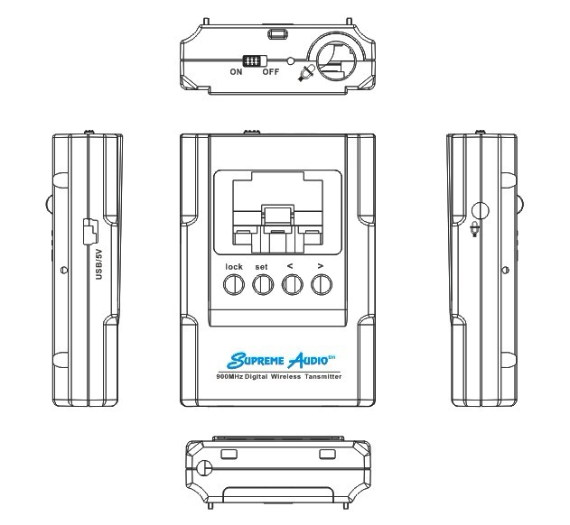
1
2
3
4
5
6
7
8
9
- Mini XLR microphone input
- ON/OFF switch
- 3.5mm microphone input
- Display
- USB/5V Input (used for charging 3 x AAA batteries)
- > Button (used to adjust the microphone gain between 0-9)
- < Button (used to adjust the low pass filter setting; this is adjustable from 1-8. The display area will go blank once it is scrolled past 8, which indicates the filter is off.)
- SET Button (used to scroll through the available channels, 1-12)
- Color TFT Display
Note: To adjust the channel, low pass filter and volume, the device needs to be in “UNLOCK” mode
LCD Display
1
2
3
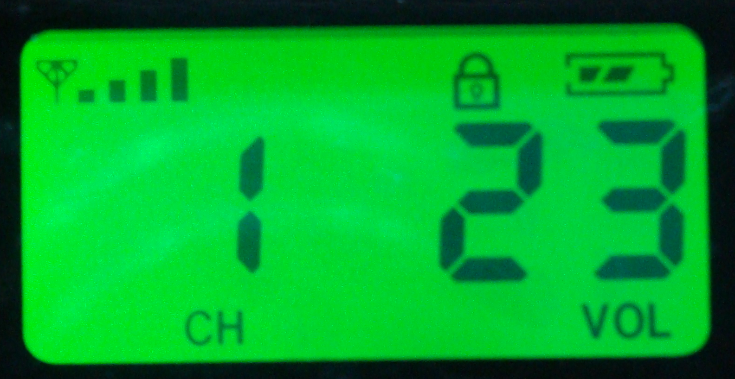
- Channel number (adjustable from 1 to 12)
- Low Pass Filter number
- Volume level (adjustable from 0 to 15)

QUICK USE GUIDE:

  - The SA95 has a battery compartment. Before use, install 3 x AAA batteries into the compartment. This device has charging function. User can charge the NI-MH batteries by using a 5V USB charger. During charging, the red LED flashes and it remains red when fully charged.
  - Match the microphone with the microphone-input jack and then insert the microphone into the proper microphone-input jack. There is a mini-XLR mic-input on the top and a 3.5mm mic input on the side.
  - Turn the power switch to “ON” position and the LCD backlight will appear.
  - Adjust the channel number to match the channel number on the receiver.
  - Adjust the microphone gain setting and the lower pass filter setting, if needed.
  - When finished using, slide the “ON/OFF” switch to the “OFF” position

Trouble Shooting Guide:

- If STATIC INTERFERENCE occurs, please go through the following procedures to eliminate the problems.
- Sound level on the transmitter may be too high.
- Check to see if any outside sources are using the same frequency as the transmitter. Either locate and remove the outside interference, or set the transmitter to a different channel to avoid that frequency.
- Check the antenna installation.
- Check the sound by connecting to a different transmitter. Listen from a receiver to see if the sound improves.
- Install new batteries into the transmitter. Make sure that the batteries are good quality and have power.
- Make sure that the antenna is upright and not located near a power cord or any metal objects.
- If the problem continues, power off the transmitter and power it on again after a minute.

- If a BUZZ occurs, please go through the following procedures to eliminate the problems.
- Make sure there are no major internal obstructions, such as metal support posts, between the transmitter and receiver.
- Make sure the antenna and receivers are installed so they are within the distance range.
- Make sure that the antenna is upright and not located near a power cord, audio cable, or any metal objects.
- Make sure the sound level on the transmitter is set to a reasonable, medium level.
- Make sure the microphone is a good one.
- Try changing the transmitter to a different frequency to see if the sound quality improves. Some will be received better than others.
- Make sure no other wireless transmitters are using the same frequency at the facility. Check to see if any outside sources are using the same frequency as the transmitter. Either locate and remove the outside interference, or change the transmitter to a different frequency to avoid that frequency.

- If there is NO SOUND, please go through the following procedures to eliminate the problems.
- Make sure the transmitter and the receiver frequencies match.
- Make sure the transmitter is ON and the batteries are fresh and fully charged.
In case the problem persists, the unit needs to be serviced. Please contact your dealer or Supreme Audio directly.

Important Safety Instructions:
Read all instructions in this guide before installing and using the equipment.
Use the good quality batteries with the equipment.
Keep the equipment away from water and moisture. Avoid dropping anything on the equipment.
Do not attempt to service the unit yourself. Contact your dealer or Supreme Audio directly for maintenance and replacements.
FCC Compliance Statement:
This device complies with Part 15 of the FCC rules. Operation is subject to the following two conditions: a. this device may not cause harmful interference; b. this device must accept any interference received, including interference that may cause undesired operation.
The SA95 wireless microphone transmitter has been tested and found to comply with the limits pursuant to Part 15 of CFR47, FCC Rules. These limits are designed to provide reasonable protection against harmful interference when operated in a residential installation. This equipment generates, uses and can radiate radio frequency energy and, if not installed and used in accordance with the manual instructions, may cause harmful interference to radio communications.
Warning: Per FCC rules, changes or modifications not expressly approved by the manufacturer could void the user’s authority to operate the equipment.

Repairs:
In the event that there is need for a repair, please contact Supreme Audio for a Return Authorization.
Supreme Audio, Inc. 155 Troy Rd., P.O. Box 550 Marlborough, New Hampshire 03455
Phone: 1-800-445-7398 or 1-603-876-3636 Fax: 1-800-346-4867 or 1-603-876-4001
Copyright © 2013 Supreme Audio, Inc. All Rights Reserved.
(8/5/13)

