
USER’S MANUAL:SUPREME AUDIO DIGITAL 900MHz SA94 Headworn Transmitter
Model No.: SA94

Introduction:
Thanks for purchasing the SUPREME AUDIO digital 900MHz SA94 waterproof headworn transmitter. This system is very reliable and easy to use. It is waterproof, submersible and lightweight! Your perfect solution for exercising. It is supported by a professional technical team who will ensure that, in the unlikely event that you experience any problem, we will work with you to solve it.
There are 12 channels available for this system which can work simultaneously.

Technical Specifications:
SA94 900MHz Headworn Transmitter
Frequency | 902.000MHz – 928.000MHz
Frequency space | 2 MHz
Channel | 12
Audio Sampling | 32KHz QPSK
Current Draw | 105mA
Battery Capacity | 600mA
Audio Frequency Response | 20Hz~15KHz
Mute | audio mute when signal lost
Concurrent Systems | 12
S/N Ratio | 80dB

Configuration:
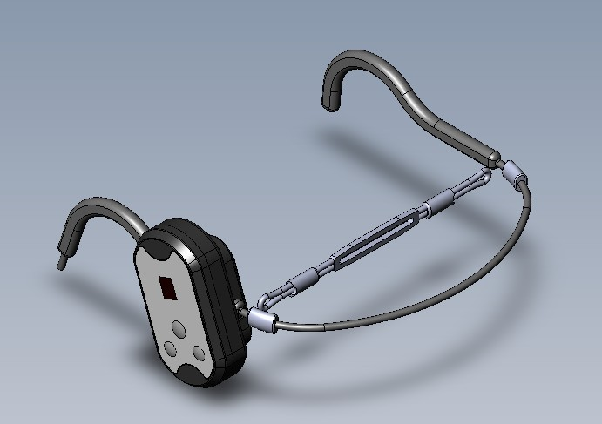
1
2
3
4
- Display (to display channel number, 1 to 9, a-c, for a total of 12 channels)
- POWER Button (used to power ON/OFF/MUTE the transmitter, press and hold it for two seconds to power on the transmitter; press once to mute and press it again to unmute; press and hold for two seconds to turn it off)
- Channel DOWN Button
- Channel UP Button
Note: In mute status, the display channel number flashes. Elastic headband appearance varies from above picture.

QUICK USE GUIDE:

  - The SA94 has a built-in lithium battery. Before use, charge the battery via the wireless charging cradle (model number SPA94CHARGER).
  - Power ON the transmitter and the LCD backlight will appear.
  - Adjust the channel number to match the channel number on the receiver.
  - When finished using, power OFF the transmitter to save the power and place it onto the charging cradle for battery charging.

SA94CHARGER CHARGING CRADLE:
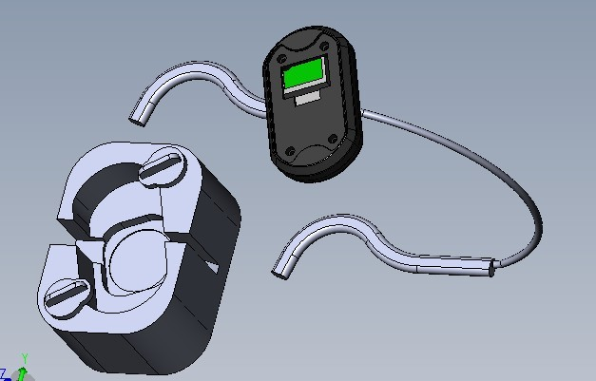
a. Place the headworn transmitter onto the charging cradle and lock the two lockers.
b. Plug the 5V power adapter into the DC input on the charging cradle.
c. It takes six to seven hours to fully charge the transmitter each time and it can be used for six hours after every full charge.
LED status
Red: charging cradle powered on
Green flashing: charging
Green on: charging completed
Trouble Shooting Guide:

- If STATIC INTERFERENCE occurs, please go through the following procedures to eliminate the problems.
- Sound level on the transmitter may be too high.
- Check to see if any outside sources are using the same frequency as the transmitter. Either locate and remove the outside interference, or set the transmitter to a different channel to avoid that frequency.
- Check the sound by connecting to a different transmitter. Listen from a receiver to see if the sound improves.
- Make sure the battery is charged and has power.
- If the problem continues, power off the transmitter and power it on again after a minute.

- If a BUZZ occurs, please go through the following procedures to eliminate the problems.
- Make sure there are no major internal obstructions, such as metal support posts, between the transmitter and receiver.
- Make sure the antennas on the receivers are installed so they are within the distance range.
- Make sure to talk to the “T-talk” side of the microphone
- Try changing the transmitter to a different frequency to see if the sound quality improves. Some will be received better than others.
- Make sure no other wireless transmitters are using the same frequency at the facility. Check to see if any outside sources are using the same frequency as the transmitter. Either locate and remove the outside interference, or change the transmitter to a different frequency to avoid that frequency.

- If there is NO SOUND, please go through the following procedures to eliminate the problems.
- Make sure the transmitter and the receiver frequencies match.
- Make sure the transmitter is ON and the batteries are fully charged.
If the problem persists, the unit needs to be serviced. Please contact your dealer or Supreme Audio directly.

Important Safety Instructions:
Read all instructions in this guide before installing and using the equipment.
Do not attempt to service the unit yourself. Contact your dealer or Supreme Audio directly for maintenance and replacements.
FCC Compliance Statement:
This device complies with Part 15 of the FCC rules. Operation is subject to the following two conditions: a. this device may not cause harmful interference; b. this device must accept any interference received, including interference that may cause undesired operation.
The SPA94 wireless entertainment transmitter has been tested and found to comply with the limits pursuant to Part 15 of CFR47, FCC Rules. These limits are designed to provide reasonable protection against harmful interference when operated in a residential installation. This equipment generates, uses and can radiate radio frequency energy and, if not installed and used in accordance with the manual instructions, may cause harmful interference to radio communications.
Warning: Per FCC rules, changes or modifications not expressly approved by the manufacturer could void the user’s authority to operate the equipment.

Repairs:
In the event that there is need for a repair, please contact Supreme Audio for a Return Authorization.
Supreme Audio, Inc. 155 Troy Rd., P.O. Box 550 Marlborough, New Hampshire 03455
Phone: 1-800-445-7398 or 1-603-876-3636 Fax: 1-800-346-4867 or 1-603-876-4001

Copyright © 2013 Supreme Audio, Inc. All Rights Reserved.
(8/5/13)

